GRE over IPsec
Name: THY DAYUTH ( 33 )
GROUP 1

Contents
Topology 2
IP Addressing Plan 2
GRE over IPsec Configuration 5
VPN Verification 6
Connectivity Testing 7
Saved Configurations 8

Topology
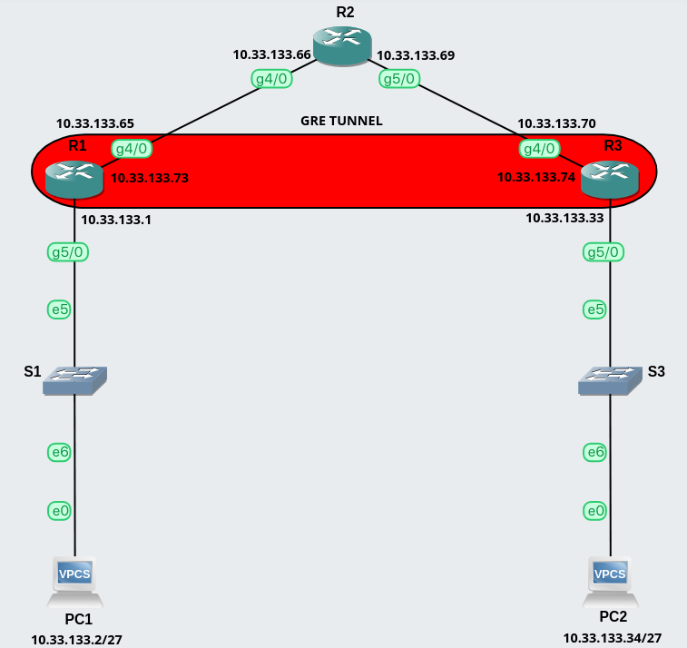

IP Addressing Plan
  - R1
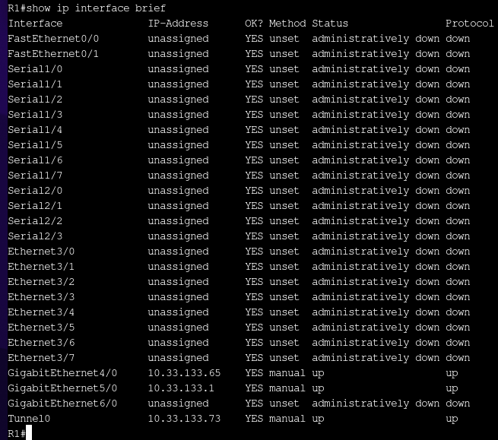
  - R2
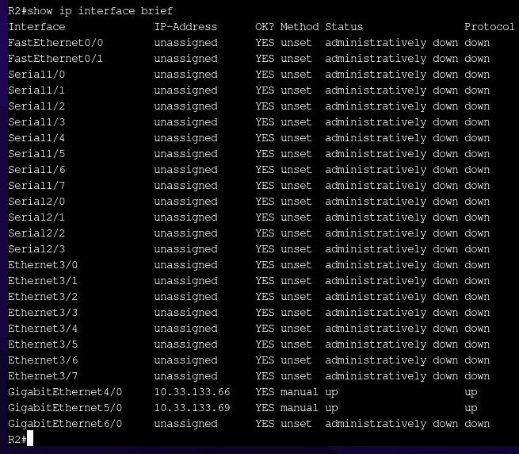
  - R3
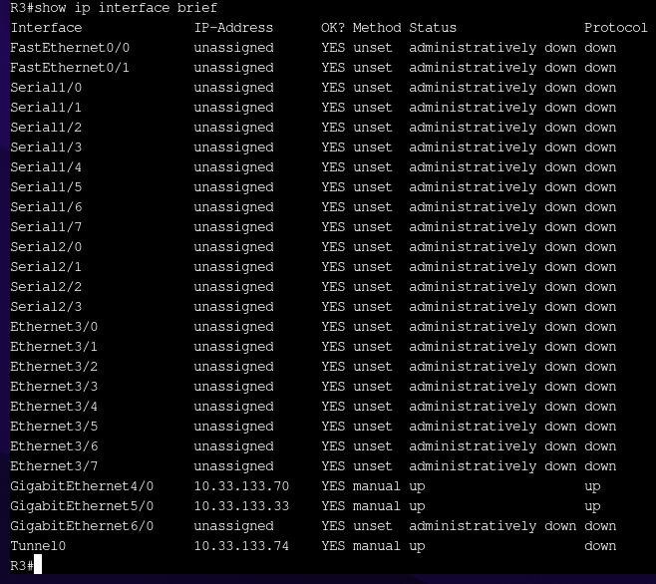
  - PC1
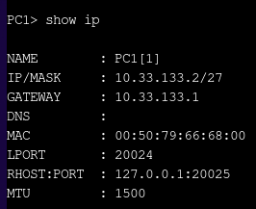

  - PC2
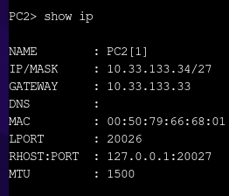

GRE over IPsec Configuration
  - R1
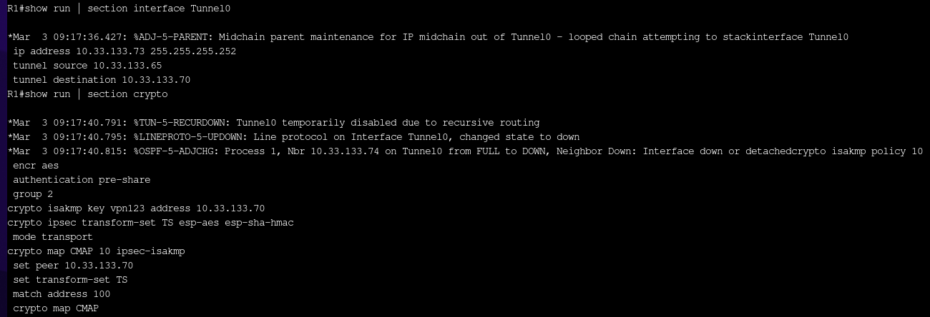
  - R2
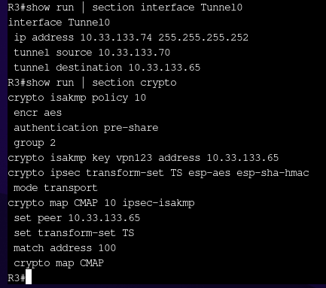

VPN Verification
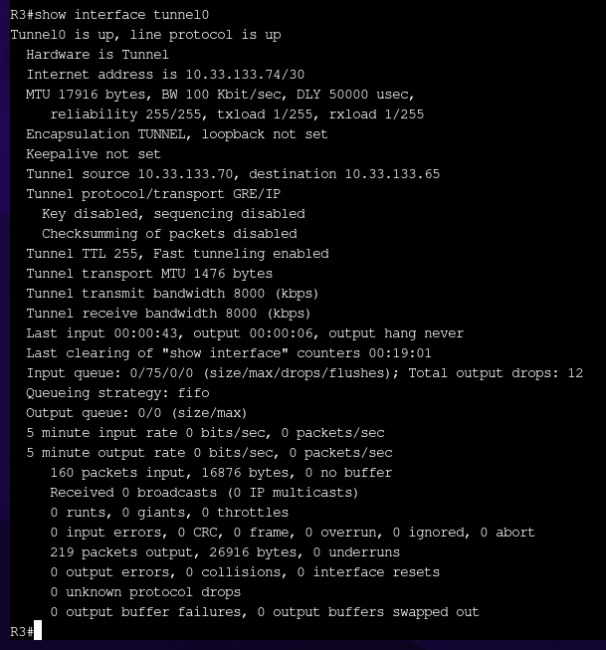

- IKE Phase 1
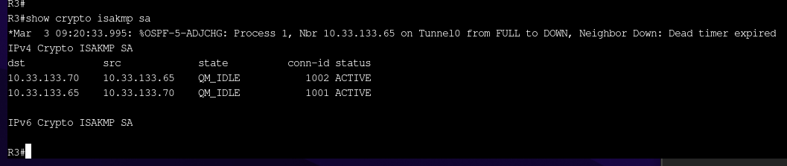

- IKE Phase 2
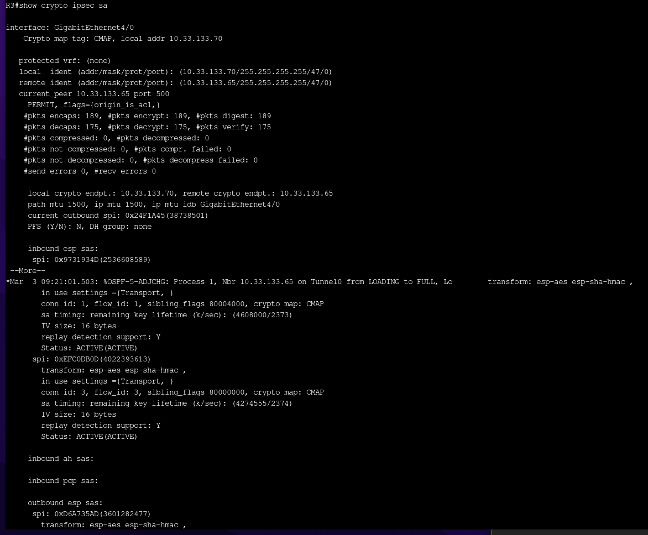

Connectivity Testing
  - PC1-PC2
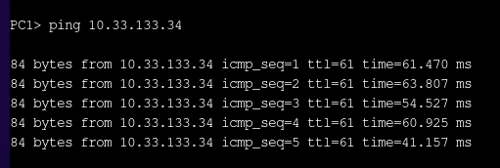

  - PC2-PC1
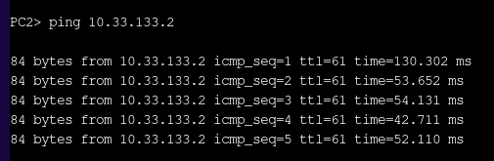

Saved Configurations
  - R1
R1#show startup-config

Using 2855 out of 129016 bytes!

!

!

! Last configuration change at 08:59:59 UTC Tue Mar 3 2026

!

version 15.2

service timestamps debug datetime msec

service timestamps log datetime msec

!

hostname R1

!

boot-start-marker

boot-end-marker

!

!

!

no aaa new-model

ip cef

!

!

!

!

!

!

no ipv6 cef

!

!

multilink bundle-name authenticated

!
!

crypto isakmp policy 10

encr aes

authentication pre-share

group 2

crypto isakmp key vpn123 address 10.33.133.70

!

!

crypto ipsec transform-set TS esp-aes esp-sha-hmac

mode transport

!

!

!

crypto map CMAP 10 ipsec-isakmp

set peer 10.33.133.70

set transform-set TS

match address 100

!

!

!

!

!

interface Tunnel0

!

ip address 10.33.133.73 255.255.255.252

tunnel source 10.33.133.65

tunnel destination 10.33.133.70

FastEthernet interface 0/0

!

no ip address

shutdown

speed auto

duplex auto

FastEthernet0/1 interface

no ip address

shutdown

speed auto

duplex auto
!

speed auto

duplex auto

interface Serial1/0

!

no ip address

shutdown

serial restart-delay 0

interface Serial1/1

!

no ip address

shutdown

serial restart-delay 0

interface Serial1/2

!

no ip address

shutdown

serial restart-delay 0

interface Serial1/3

!

no ip address

shutdown

serial restart-delay 0

interface Serial1/4

!

no ip address

shutdown

serial restart-delay 0

interface Serial1/5

!

no ip address

shutdown

serial restart-delay 0

interface Serial1/6

!

no ip address

shutdown

serial restart-delay 0

interface Serial1/7

!

no ip address

shutdown

serial restart-delay 0

interface Serial2/0

!

no ip address

shutdown

serial restart-delay 0

interface Serial2/1

interface Serial2/2

!

no ip address

shutdown

serial restart-delay 0

interface Serial2/3

!

no ip address

shutdown

serial restart-delay O

interface Ethernet3/0

!

no ip address

shutdown

duplex full

interface Ethernet3/1

!

no ip address

shutdown

duplex full

interface Ethernet3/2

!

no ip address

shutdown

duplex full

interface Ethernet3/3

!

no ip address

shutdown

duplex full

interface Ethernet3/4

!

no ip address

shutdown

duplex full

interface Ethernet3/5

!

no ip address

shutdown

duplex full

interface Ethernet3/6

no ip address

shutdown

duplex full

!
!

no ip address

shutdown

duplex full

interface Ethernet3/7

no ip address

shutdown

duplex full

i

interface GigabitEthernet4/0

!

ip address 10.33.133.65 255.255.255.252

negotiation auto

crypto map CPAR

interface GigabitEthernet5/0

i

ip address 10.33.133.1 255.255.255.224

negotiation auto

interface GigabitEthernet6/0

!

no ip address

shutdown

negotiation auto

router ospf 1

!

network 10.33.133.0 0.0.0.255 area 0

ip forward-protocol nd

!

!

no ip http server

no ip http secure-server

ip route 0.0.0.0 0.0.0.0 10.33.133.66

!

access-list 100 permit gre host 10.33.133.65 host 10.33.133.70

!

!

control-plane

!

!

line con 0

stopbits 1

line aux 0

stopbits 1

line vty 0 4

!

login

i

end

  - R2

R2#show start

R2#show startup-config

Using 2373 out of 129016 bytes!

!

!

! Last configuration change at 09:00:13 UTC Tue Mar 3 2026

!

version 15.2

service timestamps debug datetime msec

service timestamps log datetime msec

!

hostname R2

!

boot-start-marker

boot-end-marker

!

!

!

no aaa new-model

ip cef

!

!

!

!

!

!

no ipv6 cef

!

!

multilink bundle-name authenticated

!

!

boot-end-marker

no aaa new-model

ip cef

!

!

no ipv6 cef

!

i

multilink bundle-name authenticated

!

FastEthernet interface 0/0

!

no ip address

shutdown

speed auto

duplex auto

FastEthernet0/1 interface

!

no ip address

shutdown

speed auto

duplex auto
!

shutdown

speed auto

duplex auto

interface Serial1/0

!

no ip address

shutdown

serial restart-delay 0

interface Serial1/1

!

no ip address

shutdown

serial restart-delay 0

interface Serial1/2

i

no ip address

shutdown

serial restart-delay 0

interface Serial1/3

!

no ip address

shutdown

serial restart-delay 0

interface Serial1/4

!

no ip address

shutdown

serial restart-delay 0

interface Serial1/5

!

no ip address

shutdown

serial restart-delay 0

interface Serial1/6

!

no ip address

shutdown

serial restart-delay 0

interface Serial1/7

!

no ip address

shutdown

serial restart-delay 0

interface Serial2/0

!

no ip address

shutdown

serial restart-delay 0
!

interface Serial2/1

!

no ip address

shutdown

serial restart-delay 0

interface Serial2/2

!

no ip address

shutdown

serial restart-delay 0

interface Serial2/3

!

no ip address

shutdown

serial restart-delay O

interface Ethernet3/0

!

no ip address

shutdown

duplex full

interface Ethernet3/1

!

no ip address

shutdown

duplex full

interface Ethernet3/2

!

no ip address

shutdown

duplex full

interface Ethernet3/3

!

no ip address

shutdown

duplex full

interface Ethernet3/4

!

no ip address

shutdown

duplex full

interface Ethernet3/5

no ip address

shutdown

duplex full

interface Ethernet3/6

i

no ip address

shutdown

duplex full

interface Ethernet3/7

!

no ip address

shutdown

duplex full

interface GigabitEthernet4/0

!

ip address 10.33.133.66 255.255.255.252

negotiation auto

interface GigabitEthernet5/0

!

ip address 10.33.133.69 255.255.255.252

negotiation auto

interface GigabitEthernet6/0

!

no ip address

shutdown

negotiation auto

ip forward-protocol nd

!

!

no ip http server

no ip http secure-server

ip route 10.33.133.0 255.255.255.224 10.33.133.65

ip route 10.33.133.32 255.255.255.224 10.33.133.70

!

!

!

!

control-plane

!

!

line con 0

stopbits 1

line aux 0

stopbits 1

line vty 0 4

!

login

i

end

R2#

  - R3

R3#show startup-config

Using 2856 out of 129016 bytes!

!

!

! Last configuration change at 09:00:27 UTC Tue Mar 3 2026

!

version 15.2

service timestamps debug datetime msec

service timestamps log datetime msec

!

hostname R3

!

boot-start-marker

boot-end-marker

!

!

!

no aaa new-model

ip cef

!

!

!

!

!

!

no ipv6 cef

!

!

multilink bundle-name authenticated

!

!

!

crypto isakmp policy 10

encr aes

authentication pre-share

group 2

crypto isakmp key vpn123 address 10.33.133.65

!

!

crypto ipsec transform-set TS esp-aes esp-sha-hmac

mode transport

!

!

!

crypto map CMAP 10 ipsec-isakmp

set peer 10.33.133.65

set transform-set TS

match address 100

!

!

!

!

!

interface Tunnel0

!

ip address 10.33.133.74 255.255.255.252

tunnel source 10.33.133.70

tunnel destination 10.33.133.65

FastEthernet interface 0/0

!

no ip address

shutdown

speed auto

duplex auto

FastEthernet0/1 interface

!

no ip address

shutdown

speed auto

duplex auto

interface Serial1/0

!

no ip address

shutdown

serial restart-delay 0
!

interface Serial1/1

!

no ip address

shutdown

serial restart-delay 0

interface Serial1/2

!

no ip address

shutdown

serial restart-delay O

interface Serial1/3

!

no ip address

shutdown

serial restart-delay 0

interface Serial1/4

!

no ip address

shutdown

serial restart-delay O

interface Serial1/5

!

no ip address

shutdown

serial restart-delay 0

interface Serial1/6

!

no ip address

shutdown

serial restart-delay O

interface Serial1/7

!

no ip address

shutdown

serial restart-delay 0

interface Serial2/0

!

no ip address

shutdown

serial restart-delay O

interface Serial2/1

!

no ip address

shutdown

serial restart-delay 0
!

interface Serial2/2

!

no ip address

shutdown

serial restart-delay 0

interface Serial2/3

!

no ip address

shutdown

serial restart-delay 0

interface Ethernet3/0

!

no ip address

shutdown

duplex full

interface Ethernet3/1

!

no ip address

shutdown

duplex full

interface Ethernet3/2

!

no ip address

shutdown

duplex full

interface Ethernet3/3

!

no ip address

shutdown

duplex full

interface Ethernet3/4

!

no ip address

shutdown

duplex full

interface Ethernet3/5

!

no ip address

shutdown

duplex full

interface Ethernet3/6

no ip address

shutdown

duplex full

!

!

interface Ethernet3/7

!

no ip address

shutdown

duplex full

interface GigabitEthernet4/0

ip address 10.33.133.70 255.255.255.252

negotiation auto

crypto map CPAR

interface GigabitEthernet5/0

!

ip address 10.33.133.33 255.255.255.224

negotiation auto

interface GigabitEthernet 6/0

!

no ip address

shutdown

negotiation auto

router ospf 1

!

network 10.33.133.0 0.0.0.255 area 0

ip forward-protocol nd

!

!

no ip http server

no ip http secure-server

ip route 0.0.0.0 0.0.0.0 10.33.133.69

i

access-list 100 permit gre host 10.33.133.70 host 10.33.133.65

!

!

i

control-plane

!

!

line con 0

stopbits 1

line aux 0

stopbits 1

line vty 04

login

!

!

end

R3#

